|  |  |
| --- | --- |
|  | [Yong Seung Rho] |

Memo

**To:** Bill Cunningham

**From:** Yong Seung Rho (W0447442@nscc.ca)

**Date:** December 4th, 2020

**Subject:** The analysis of the best running refreshment sales

The purpose of this memo is to share with you how to increase revenue and reduce cost from Bestrunrefreshmentsales.csv as follows.

1. Existing system

* This data is about a business that distributes “refreshments” in the west coast states of the USA. These states are California, Nevada, and Oregon.
* This includes three years’ data like revenue, profit and quantity sold from 2013 to 2015.
* This sheet contains information on cities along with coordination in each state.
* The products with categories can use to analyze.

2. Statement of Requirement

* Figure out how to increase revenue or decrease cost.
* It costs money to ship our products to the buyers. If we had to locate one single distribution warehouse for all of the customers, where should it be.
* Give the answers to the following questions.
  + Which products generate the most revenue?
  + Is there a sales trend by product?
  + Which customers generate the most revenue?
  + Is there a sales trend by customers, or by region?
  + Is there a type of beverage that is more popular?
  + Should we develop more products of a certain type?

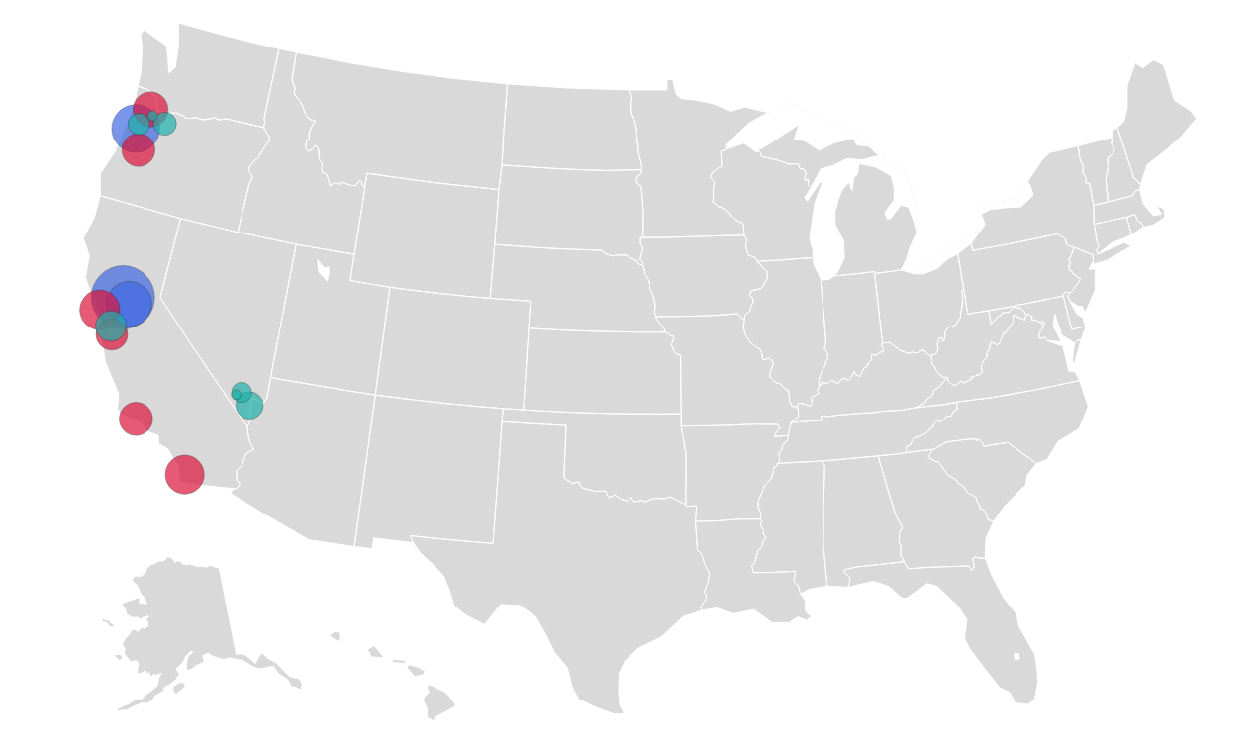

3. Analysis

* In the graph, the revenue sharply increased from Q2/2014 to Q4/2014. After that, it remained steady by Q3/2015 and dropped in Q4/2015. The revenue reached $115,845,708 in Q1/2015. The profit steadily increased by Q2/2015. After that, it slightly decreased.

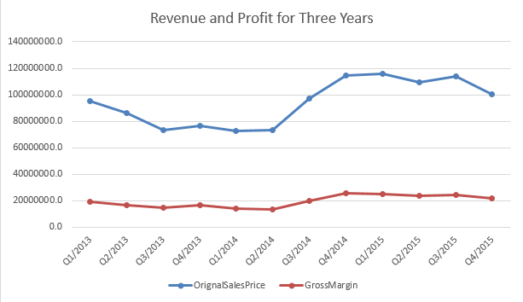

* There were 317 stores in California, Oregon had 91 stores, and 33 stores were in Nevada.

California was the biggest market in three west coast states of the USA. It accounted for 64% in revenue, and 74% in profit, respectively. By contrast, Nevada made up only 10% and %6.

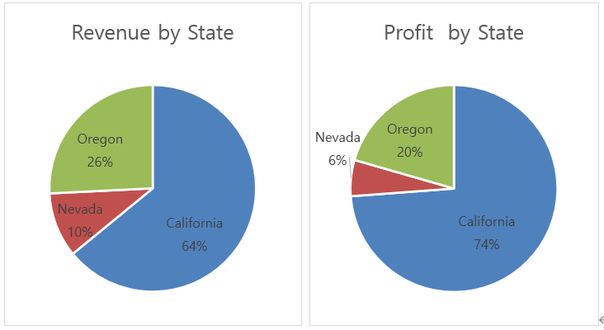

* There were 18 cities. Approximately 60% of revenue came from the top six cities such as Los Angeles, Salem, Sacramento, San Francisco, San Diego, and Portland. The biggest market of the cities was Los Angeles that generated 18% of the revenue. Four of the top six cities are in California. If we had to locate one single distribution warehouse for all of the customers, the location would be between Los Angeles and San Francisco because this location is close to the cities where many stores are, and the shipping cost can reduce.

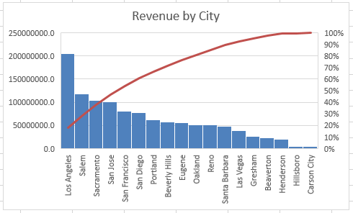

* Next, 65% of revenue came from the Juices category such as Apple, Orange, Mango, and so on. The following category was Alcohol like IPA, Lager, Wine, etc. On the other hand, 59% profit generated by Juices, and Carbonated Drinks occupied 26% of the profit. Whereas Juices had a large share in the revenue, the cost was higher than Carbonated Drinks relatively. Carbonated Drinks was better than Juices in profit-to-sales ratio. However, Energy Drinks and Others rarely affected the revenue and the cost.
* If a lot of Juices sold, it would help to increase the revenue. If a lot of Carbonated Drinks sold, it would help to increase the profit.

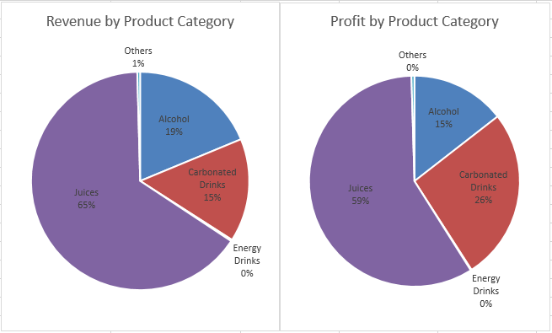

* The revenue of Juices and Alcohol gradually decreased after reaching a peak in Q4/2014. Alcohol significantly dropped in Q4/2014. After that, The Carbonated Drinks was higher than Alcohol. The sales trend by customer changed from Q4/2014. The customers preferred Carbonated Drinks to Alcohol.

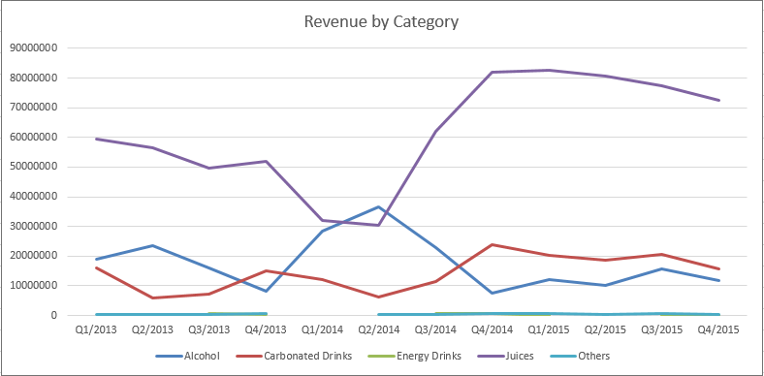

Almost 90% of Juices revenue came from Orange with pulp, and Dark Beer in the revenue made up approximately 65% in Alcohol.

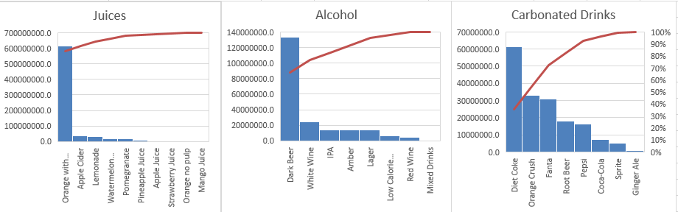

* If we had to locate one single distribution warehouse for all of the customers, and reduce the shipping cost, it would be the best place where the location was between Los Angeles and San Francisco.
* Most of the revenue in the west coast states of the USA came from Orange Pulp and Dark Beer from the data. We need to develop a new potential product that can increase the revenue like Diet Coke or Orange Crunch because its profit-to-revenue ratio is better than others.

4. Conclusion

There are many ways to increase revenue and reduce cost. In this case, we should consider moving or setting up a new distribution warehouse to reduce the cost. It is necessary to strengthen existing products to increase the revenue and the profit by advertising. Also, customers’ need keeps changing, so we must prepare and develop new products for the future.